**Ideation Phase**

**Brainstorm & Idea Prioritization**

|  |  |
| --- | --- |
| Date | 18 June 2025 |
| Team ID | LTVIP2025TMID30187 |
| Project Name | Optimizing User, Group, and Role Management with Access Control and Workflows |
| Mentor Name | Dr Shaik Salma Begum |
| Maximum Marks | 4 Marks |

### ****Brainstorm & Idea Prioritization****

Brainstorming was conducted to explore possible solutions for the identified problem in managing users, groups, roles, and workflows within small project teams. The objective was to find effective ways to enforce accountability and structured task handling by using ServiceNow’s capabilities.

This collaborative phase allowed the team to express a wide variety of ideas related to access control, automation, and workflow design. The emphasis was on generating both conventional and innovative suggestions without immediate evaluation.

**Key aspects of the brainstorming process included:**

* Generating high-volume ideas before assessing feasibility.
* Welcoming creative, role-based, and workflow-driven solutions.
* Promoting teamwork to combine and enhance individual suggestions.
* Using shared online templates to record and organize all ideas systematically.

Key aspects of the brainstorming process included:

* Encouraging **volume over immediate value**, to ensure all potential solutions were surfaced.
* Welcoming and building upon unconventional or novel ideas.
* Fostering collaboration, where team members supported and enhanced each other's suggestions.
* Using a shared template to capture ideas in a structured manner, making it easy to review and prioritize them later.

### ****Following the Idea Generation Phase, the Team Prioritized Based on:****

* Feasibility within ServiceNow's platform capabilities.
* Simplicity in implementation within the project timeline.
* Effectiveness in solving the lack of clear user roles and access restrictions.
* Automation potential and ability to reduce manual errors.
* Overall impact on accountability, transparency, and task traceability.

This structured brainstorming and prioritization helped the team identify and commit to key features such as:

* Role-Based Access Control (RBAC)
* Automated task workflow states (Created → Assigned → In Progress → Completed)
* Real-time notifications and alerts
* Audit trails to track task ownership and changes
* Secure task visibility and editing based on roles.

**Step-1: Tem Gathering, Collaboration and Select the Problem Statement**

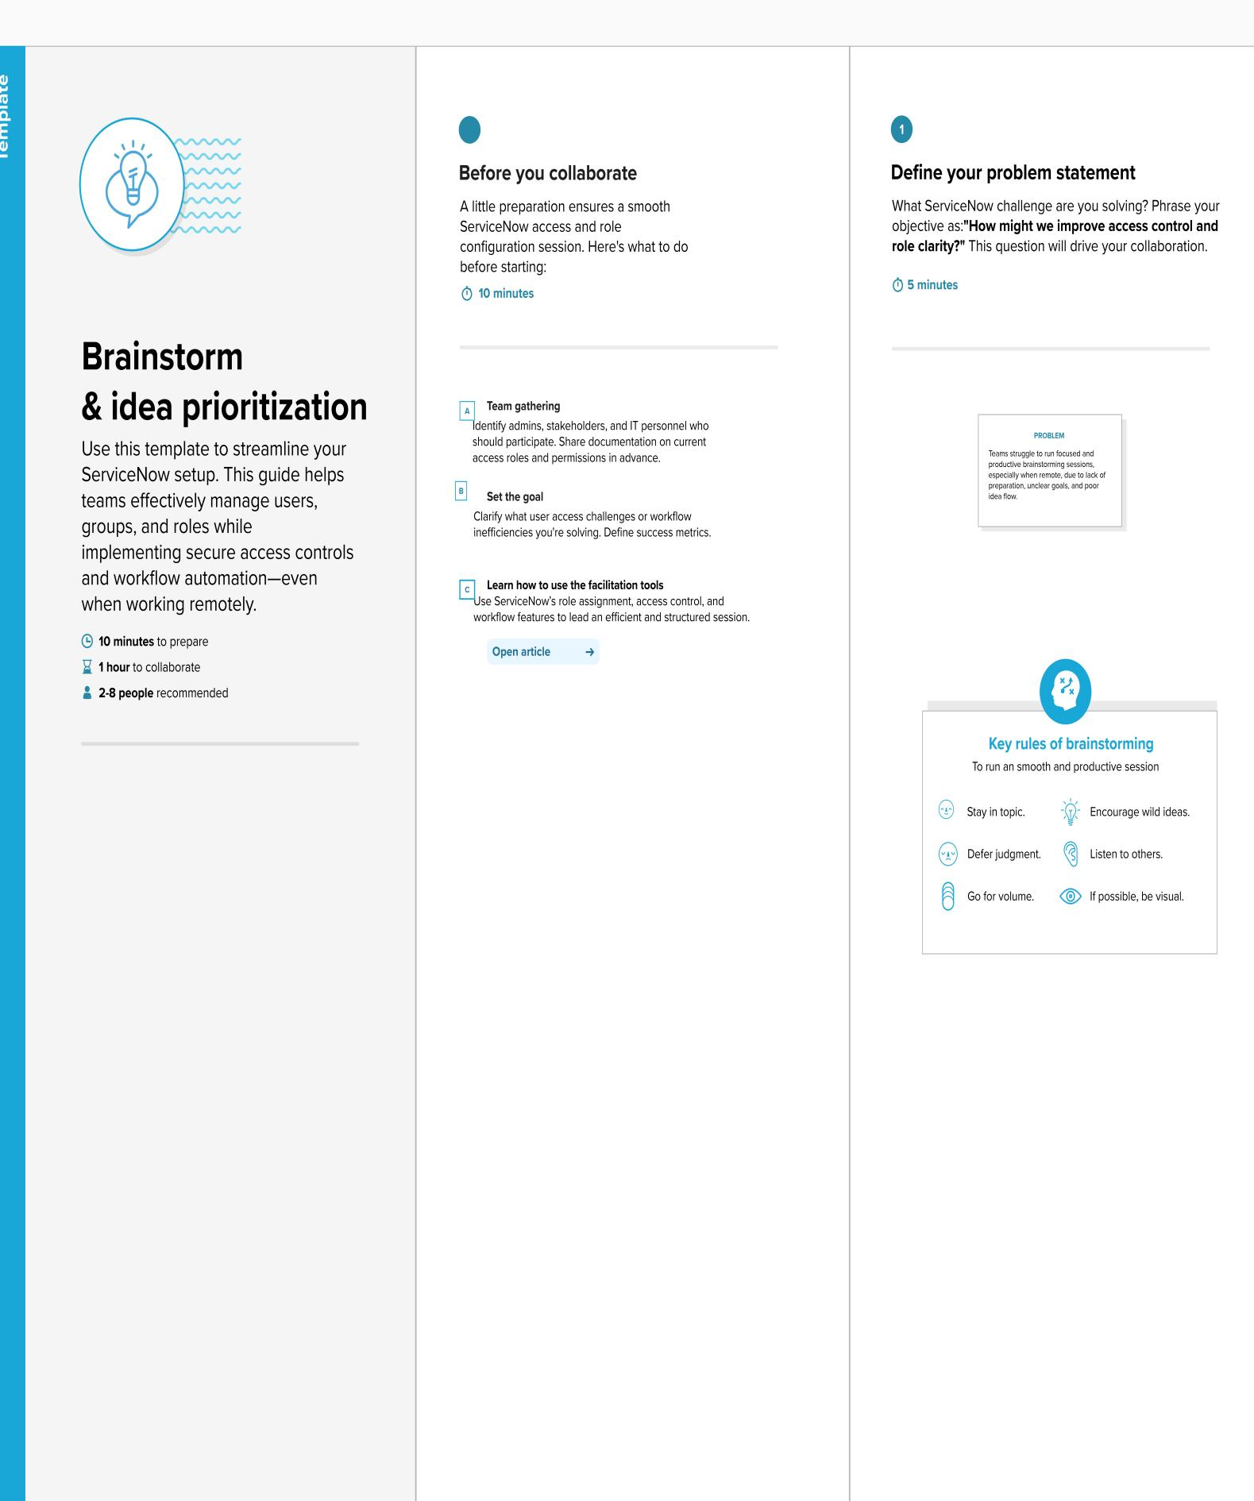

**Step-2: Brainstorm, Idea Listing and Grouping**

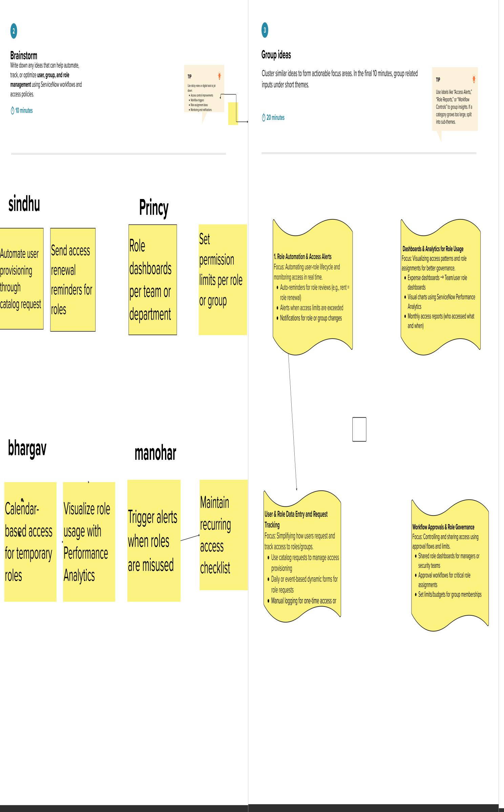

**Step-3: Idea Prioritization**

